 | 12.1.37 Editors - Geometry Nodes Editor - Header - Add Menu - Volume - Write
Table of content
Detailed table of content 1
Add menu - Volume 2
Grid Background 2
Set Grid Transform 3
Store Named Grid 3

Detailed table of content
Detailed table of content
Detailed table of content 1
Add menu - Volume 2
Grid Background 2
Inputs 2
Grid 2
Background 2
Properties 2
Data Type 2
Output 2
Grid 2
Set Grid Transform 2
Inputs 3
Grid 3
Transform 3
Properties 3
Data Type 3
Output 3
Is Valid 3
Grid 3
Store Named Grid 3
Inputs 3
Volume 3
Name 3
Grid 3
Properties 3
Data Type 3
Output 4
Volume Geometry 4

´

Add menu - Volume

Here you find nodes to modify the volume.

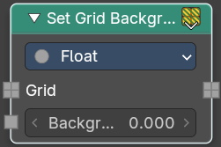
Grid Background
Set the background value used for inactive voxels and tiles.

Inputs

Grid
Standard geometry input.

Background
Volume density per voxel. Higher values makes it more dense.

Properties

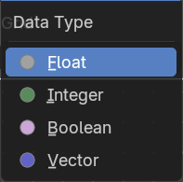
Data Type
What data type to calculate.

Output

Grid
The grid output.

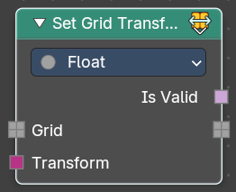
Set Grid Transform
Set the transform for the grid from index space into object space.

Inputs

Grid
Standard geometry input.

Transform
The input transform.

Properties

Data Type
What data type to calculate.

Output

Is Valid
If the new transform is successfully applied and working.

Grid
The grid output.

Store Named Grid
Set the transform for the grid from index space into object space.

Inputs

Volume
The volume input.

Name
The name

Grid
Standard geometry input.

Properties

Data Type
What data type to calculate.

Output

Volume Geometry
The volume geometry to add to.

